**1. Changes in net worth**

From the following table of transactions between two users, write a query to return the change in net worth for each user, ordered by decreasing net change.

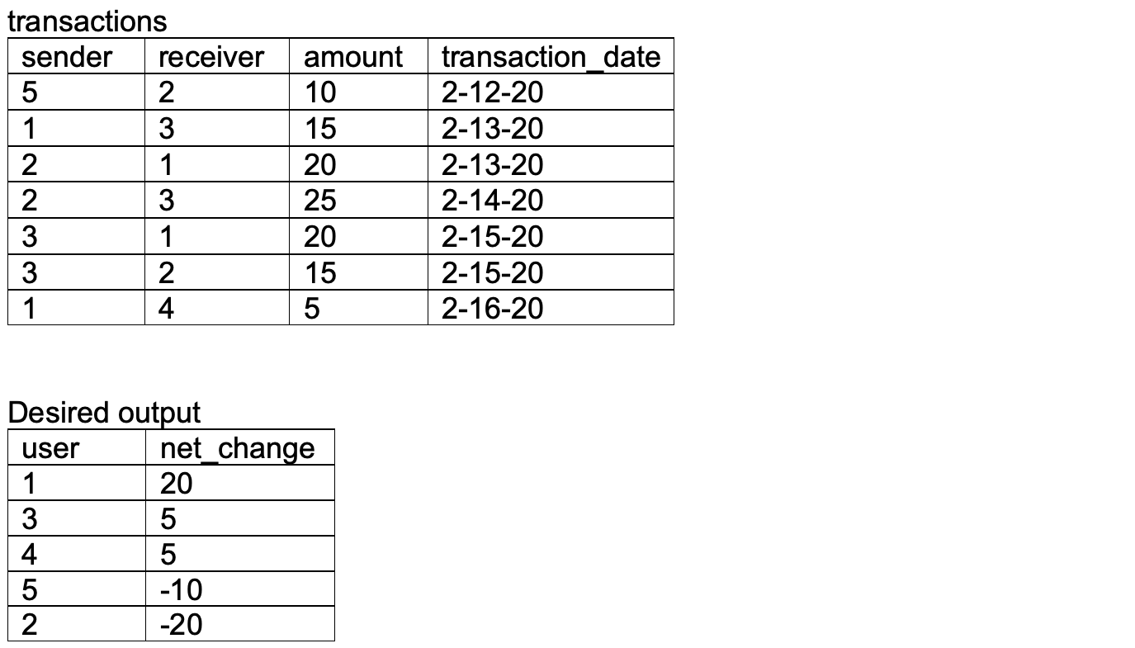

1. Create above table (transactions) and insert values
2. Sum amounts for each sender (debits) and receiver (credits),
3. Full (outer) join debits and credits tables on user id, taking net change as difference between credits and debits, coercing nulls to zeros with coalesce()